## Source Booklet – Gallipoli

**Source 1**

*(‘*The Anzac Book. Written and Illustrated in Gallipoli by the Men of Anzac’. *Published in 1916.)*

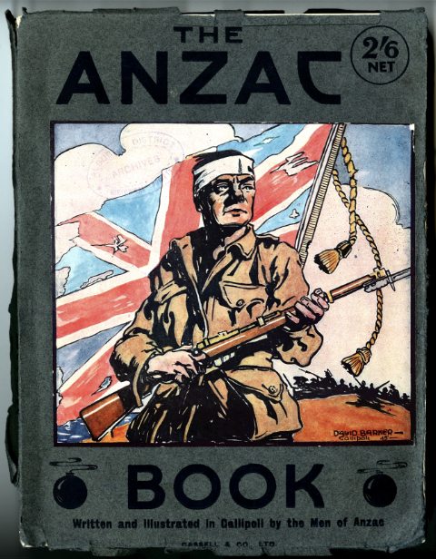

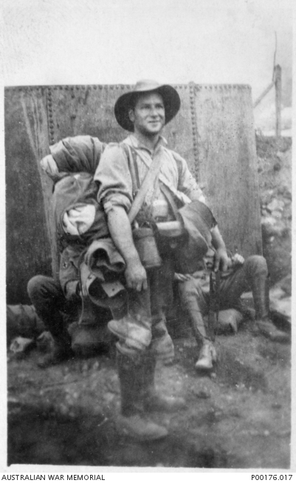

**Source 2**

*(Photograph of an Australian soldier, Doc Cherry,*

*taken on the day of evacuation from ANZAC Cove,*

*Gallipoli, Turkey, December 1915.)*

**Source 3**

*(Extract from the Australian War Memorial travelling exhibitions,* Gallipoli: a Turkish view*, 2005.)*

Gallipoli is of profound1 importance to the national identity of both Australia and Turkey. The events of 1915 created the Anzac legend, arguably the central national founding myth for Australia. For Turkey the defeat of foreign invasion under the charismatic2 command of Mustafa Kemal (later Ataturk, the founder of the modern Turkish republic) gave Gallipoli mythic status within Turkey's national identity. The conjunction3 of these powerful national stories reflects the main cultural bond between Australia and Turkey. This explains the enduring attachment of both nations to the story of the campaign, and the strong mutual interest in the other's experience and memory.

1 profound – significant

2 charismatic – impressive

3 conjunction ­– joining

**Source 4**

*(Extract from former Prime Minister Paul Keating’s speech at a book launch in 2008. The book was* Churchill and Australia*, written by Graham Freudenburg.)*

On the one hand we were out to prove that 'the British race in the antipodes1 had not degenerated2’ yet we resented being dragooned3 into a war which did not threaten our own country or its people.

The truth is that Gallipoli was shocking for us. Dragged into service by the imperial [British] government in an ill conceived4 and poorly executed campaign, we were cut to ribbons and dispatched.  
  
And none of it in the defence of Australia. Without seeking to simplify the then bonds of empire and the implicit sense of obligation, or to diminish the bravery of our own men, we still go on as though the nation was born again or even, was redeemed5 there. An utter and complete nonsense.

For these reasons I have never been to Gallipoli and I never will.

1 antipodes – Australia and New Zealand

2 degenerated – become worse

3 dragooned – forced

4 ill conceived – poorly planned

5 redeemed –proved worthy

**ACKNOWLEDGEMENTS**

**Source 1** *The Anzac book* [Front cover]. (1916). London: Cassell. Retrieved February, 2015, from http://nla.gov.au/nla.obj-19061379 [National Library no. 19061379].

**Source 2** Image: P00176.017 (*Gallipoli, Turkey, 1915-12-13. Doc Cherry taken on day of evacuation Anzac*). (1913). Retrieved February, 2015, from www.awm.gov.au/collection/P00176.017/

**Source 3** Australian War Memorial. (2015). *Travelling exhibitions: Gallipoli: A Turkish view*. Retrieved February, 2015, from https://www.awm.gov.au/exhibitions/gallipoli/

**Source 4** Keating, P. (2008). Paul Keating's speech. *Sydney Morning Herald*. Retrieved February, 2015, from www.smh.com.au/national/paul-keatings-speech-20081031-5f1h.html

**©** Copyright